**MINI-PROJECT**

**(2020-2021)**

**BLOGGING APP**

**(App Development)**

**MID-TERM REPORT**



**TEAM MEMBERS**

**AYURISH CHANDNA**

**(181500166)**

**AMAN KUMAR**

**(181500072)**

**SUPERVISED BY**

**Mr. AKASH KUMAR CHOUDHARY**

(Asst. Professor)

**Department of Computer Engineering and Applications**

**Institute of Engineering and Technology**

**Content**

Abstract

1. Introduction

1.1 General Introduction to the topic

1.2 Area of Computer Science

1.3 Hardware and Software Requirements

1. Problem definition
2. Objectives
3. Implementation Details
4. Progress till Date
5. Some Screenshots
6. References

**Abstract**

We are developing a Blogging App. There is at most need for this nowadays. Many students who are not fortunate enough to study in schools or colleges. If we have got this opportunity to study then why not do something good and contribute to our Nation. Even its seen that how students are just following the set lanes and getting a degree but they all lack skills. The main cause is a lack of mentorship. The age between 20-25 is very crucial.

This project will give a very crucial contribution to the field of education among college students who are unclear about how to build a successful career. It will boost the student's confidence and motivation. It will also help students in developing various skills like trending technical skills, decision making, storytelling, communication skills, marketing skills, etc. It will help students getting clear what are their interests and how to convert that interest into a profession. It will help our country to increase the employability level.

Flutter helps in building apps very efficiently. Flutter allows developers to build apps for both major platforms, including Android and iOS, with a single code base, therefore allowing start-ups to save a high cost on development services. Flutter has an efficient yet portable GPU rendering UI that allows it to work on multiple interfaces.

**Introduction**

* 1. **General Introduction to the topic**

It's said that "The more you share knowledge with someone the more you gain knowledge". When we do google search regarding any topic we all get lots of resources but getting a right and useful resource at the right time is still a challenging problem. These lots of resources bring confusion among students also what to do and what not to do. Keeping this in mind we decided to move forward and make a blogging app that can help students get connected to the right person or a mentor who can guide you and give you a cutting edge knowledge and share his experience in a field in which you want to make your career.

Blogging comes in many forms, it addresses countless topics, and it can, without a doubt, be divided by its quality. But when it comes to education, blogging can be an excellent tool for improving a student’s involvement, excitement, and most importantly, writing skills.

* 1. **Area of Computer Science**

Android App development is an open source operating system, based on Linux kernel and used in mobile devices like smartphones, tablets etc. Further, it was developed for smart watches and Android TV. Each of them has a specialized interface. Because it is Android Open Source Project (AOSP) licensed under the Apache license, many developers has been contributed in android development. The primary goal of the android project is to create product that can be implemented in user’s life.

As the world's most popular mobile platform, Android powers hundreds of millions of mobile devices in more than 190 countries around the world. It has the largest installed base of any mobile platform and is still growing fast. Every day another million users power up their Android-powered devices for the first time and start looking for apps, games, and other digital content.

There are many languages to build android apps like **Java, Kotlin, Flutter.**

**Why Flutter ?**

**Open-Source and Free to Use**

Both Flutter and the underlying programming language, [Dart](https://appinventiv.com/blog/google-releases-dart-2-5-and-flutter-1-9/) are open-source and free to use. This empowers developers to view the documentation, post their queries in the open developer forum, and eventually, learn and implement the code.

**Hot Reload Functionality**

One of the biggest reasons why Google Flutter is preferred by mobile application development agencies is its hot reloading functionality.

The functionality makes it easier for anyone to make any change at the backend and view the difference at the front-end simultaneously. And this way, easily decide whether the change looks perfect with other elements of the application or not.

**Lower Development Timeline and Cost**

One of the prime benefits of focusing on Flutter development is that it renders opportunities to create native-like apps for both iOS and Android using a single codebase. Something that makes the [cost to create a Flutter mobile app](https://appinventiv.com/blog/flutter-app-development-cost/) considerably low.

**Support for Google Firebase**

With the facility of Firebase integration, Flutter enables developers to add backend facility into the development environment.

### **Flutter Testing Support**

It is commonly known among the developers that Native Android tools support testing. Testing for native apps can be done using the command line of Gradle. One can add elements, integration and UI tests for Android apps. Numerous frameworks in Java and Kotlin are available got lower-level testing and also for UI testing. There are various levels of testing Android apps.

Flutter provides solid testing that allows quality analysts to write tests at various levels of such as unit, UI. One of the best features Flutters offers is Widget testing which runs UI test fast, equivalent to unit tests. If you are a beginner Flutter developer, you can refer to several levels of testing Android apps in this [shell](https://flutter.dev/docs/testing). It runs in a separate process that can be run on real devices or emulators. Flutter has a separate package called Flutter Driver to drives the test in an easy manner.

**According to Stack overflow :**

*Flutter ranks higher with 75.4% and React Native also made the cut with 62.5% among most loved frameworks.*

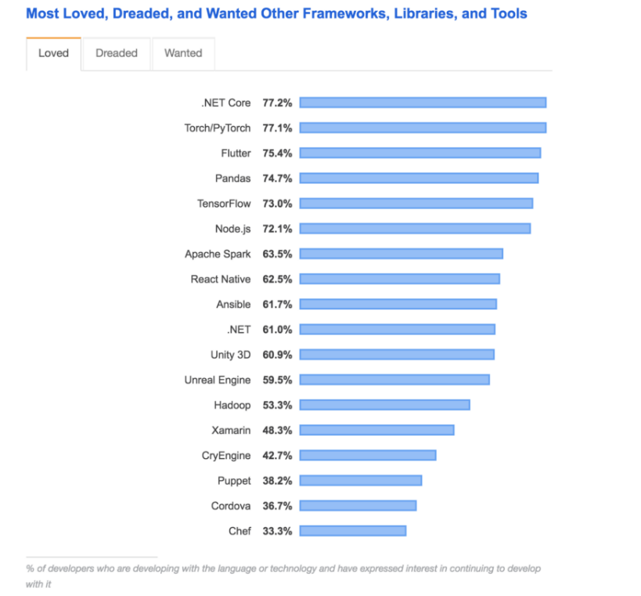

* 1. **Hardware Requirements**

1. **System Software**

* Operating System (Windows 10, Linux)
* Core i3 Processor (minimum)
* Minimum 4 GB Ram

**Software Requirements**

1. **Application Software**

- Android Studio

1. **Programming Language**

-Flutter

1. **Back-end**

**-**FireBase

**Objective**

The main objective of this blogging app is for college students. Many students who are not fortunate enough to study in schools or colleges. If we have got this opportunity to study then why not do something good and contribute to our Nation. Even its seen that how students are just following the set lanes and getting a degree but they all lack skills. The main cause is a lack of mentorship. The age between 20-25 is very crucial. Everything depends on this.

Seeing this we are creating a blogging app specially designed for college students. An app that can revolutionize the entire college journey.

In this App, students will post their achievements, their journey how they started as a beginner, and how they acquired the right knowledge and what all challenges they faced while walking on that path. Achievements can be shared in any field whether it's competitive programming, competitive exams, interview preparation, entrepreneurship, or how they acquired knowledge to learn that technology. These articles that will be posted will give clarity to students what all important aspects we have to cover while making a career in that particular domain. not only that it will also help students develop a healthy relation among students but also help students to develop a quality to help each other and do selfless service to this world.

**Implementation Details**

**Part1: Designing UI**

* Login page
* Sign Up form
* Navigation Drawer
* Home Page

**Part2: Backend work**

* Configuring Firebase for android apps
* Firebase Authentication (Signup, Login and Logout) using Firebase
* Upload Image to Firebase
* Retrieve Data from Firebase

**Progress**

**Part1:**

**Building of Login Page**

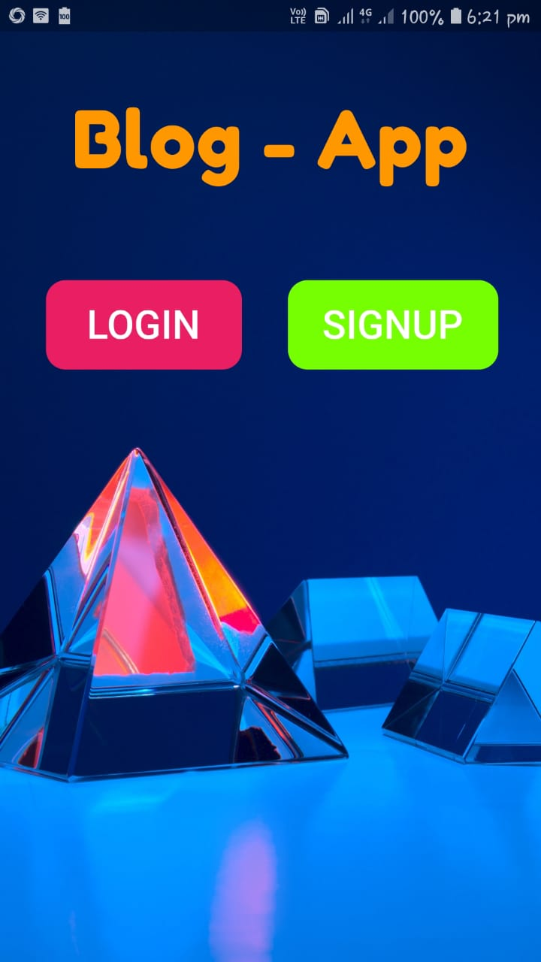

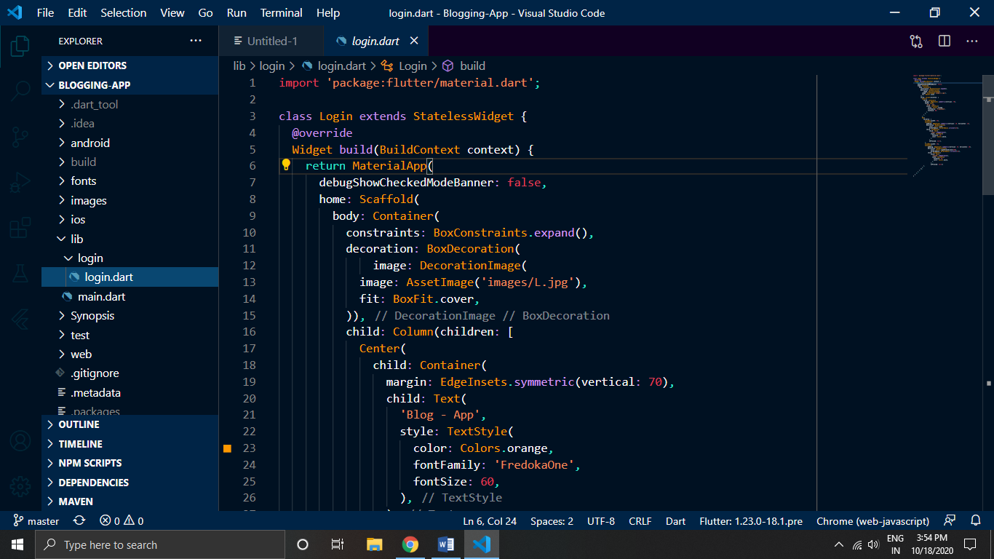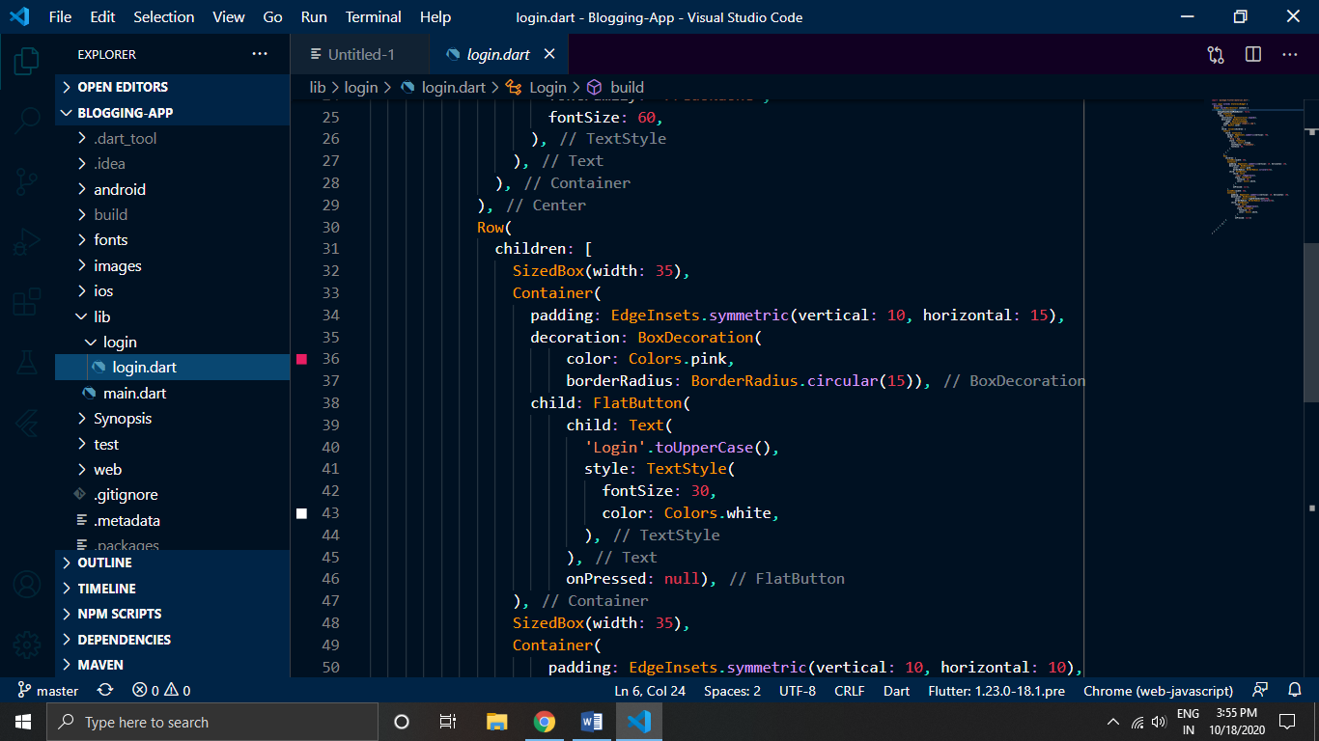

**––**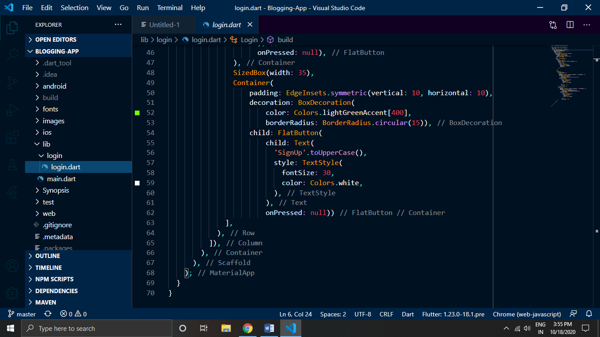

**References:**

<https://medium.com/@adhithiravi/react-native-vs-flutter-what-are-the-differences-b6dc892f0d34>

<https://theninehertz.com/blog/do-flutter-app-development-dominate-android-by-2023>

<https://appinventiv.com/blog/flutter-vs-react-native/>